Q-4:

This is the playbook I have written in order create a user with home directory and added them to sudo group

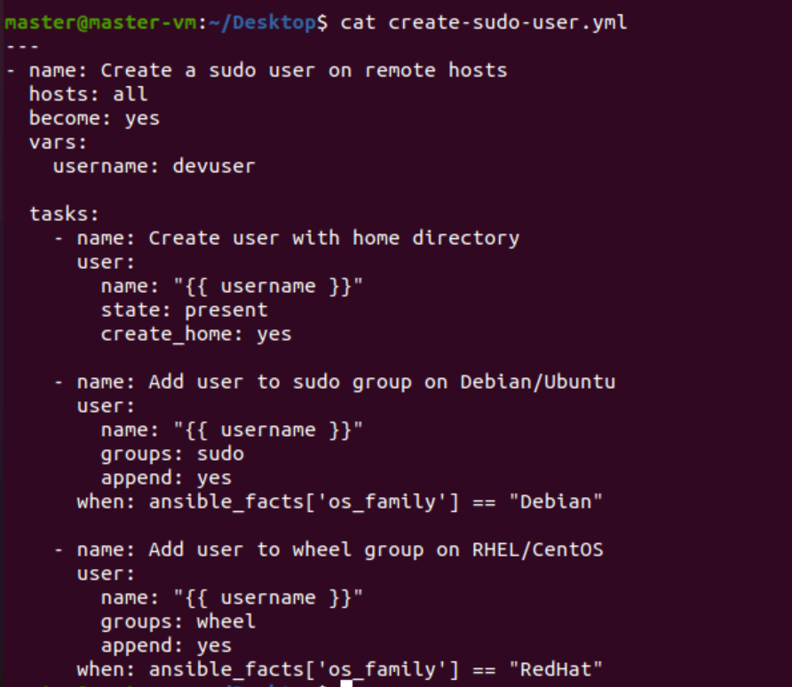

Output: after running the play book as usual hosts file contain the master and worker nodes:

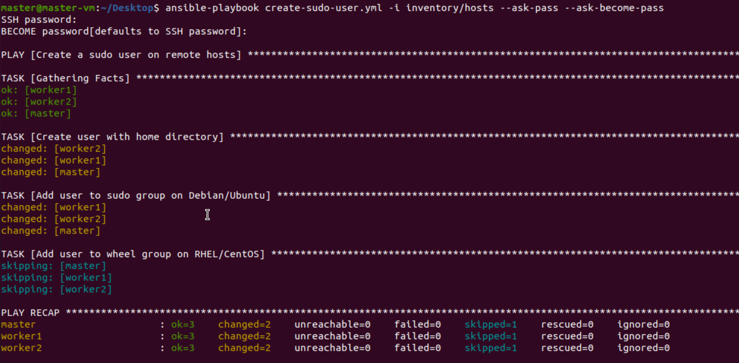

With username Jithendra: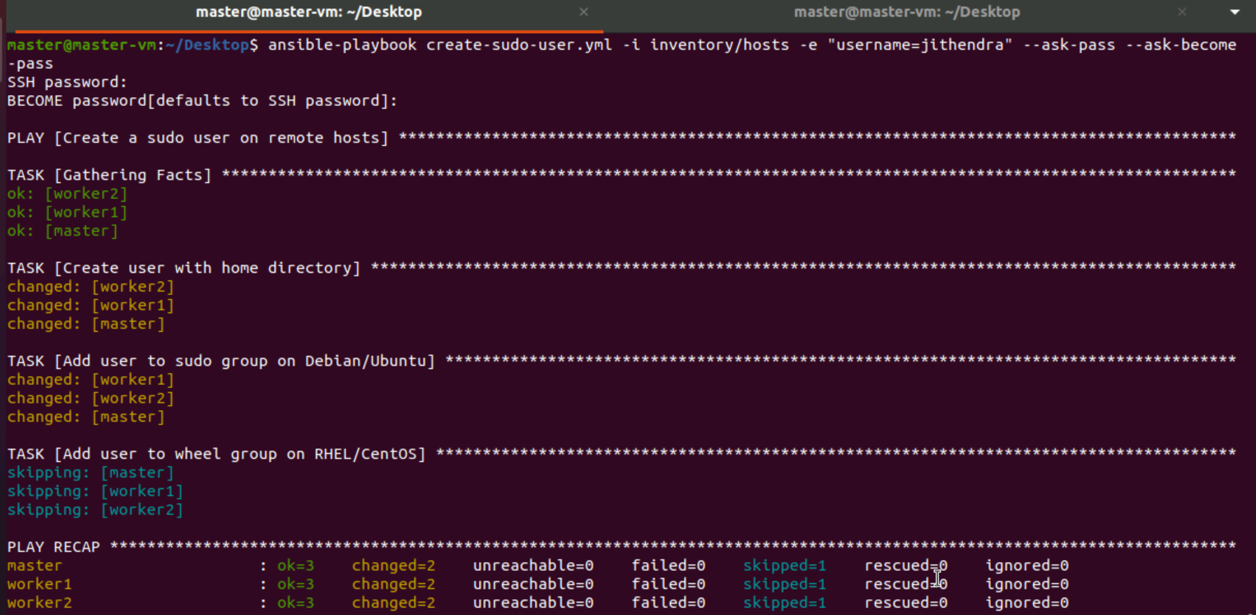

Checking whether its created or not: